6-10-2021

Zero Carbon Oxford Partnership
2040 Net Zero Action Plan
Summary
July 2021

Zero Carbon Oxford is a partnership that brings together universities, hospitals, councils, large businesses, and communities to support the city in its journey to net zero carbon emissions. Those who have signed the Zero Carbon Oxford charter have committed to working together to create a zero carbon Oxford and to collaborate to build a prosperous, sustainable city in which all can share.

The Carbon Trust’s mission is to accelerate the move to a sustainable, low carbon economy. It is a world leading expert on carbon reduction and clean technology. As a not-for-dividend group, it advises governments and leading companies around the world, reinvesting profits into its low carbon mission.

Authors

Emma Ashcroft
Associate Director
Emma.Ashcroft@carbontrust.com
Frances Bean
Manager
Frances.Bean@carbontrust.com
Charlie McNelly
Associate
Charlie.McNelly@carbontrust.com
Ben Robertson
Analyst
Ben.Robertson@carbontrust.com

Introduction
The Zero Carbon Oxford Partnership (ZCOP), comprising 21 business leaders from the Oxford’s universities, institutions, and large businesses, has committed to collaborate on achieving net zero carbon emissions for the city of Oxford by 2040. This is more ambitious than the national UK Government target, which aims for net zero by 2050. It is an expression of Oxford’s understanding that the Climate Emergency requires radical and urgent transition and a recognition that the city is already a leader in the UK and should continue to lead ‘from the front’.
To support the ZCOP in achieving this vision, the Carbon Trust has worked collaboratively with Oxford City Council and all members of the Partnership to develop and model a pathway to show what net zero by 2040 looks like in terms of emissions reduction, breaking this down into Roadmaps of key milestones to get to 2040, and develop an Action Plan setting out key actions to achieve it.
Achieving the net zero target requires a ‘whole-city approach’. Key actors from across the domestic, commercial, industrial, institutional and transport sectors will need to work together, and with the electricity and gas distribution network operators, to unlock transformational change. Collaboration, involvement, and input from ZCOP partners has been critical to the development of this project. Partners provided crucial data and steer for the scenario updates, Roadmaps, and Action Plan.
Assumptions behind the scenario, which forms the basis for the Roadmap and from which the interventions in the Action Plan stem, were subject to several rounds of review via workshops and one-to-one sessions with ZCOP partners before validation. In addition to workshops that focused on the scenario and roadmaps, five sector-themed workshops (domestic, commercial, industry, institutional and transport) were used to collaboratively ideate potential actions feeding into the Action Plan.

Scenario modelling
The scenario modelling provides a potential decarbonisation pathway to demonstrate the scale of decarbonisation that must be achieved across GHG emission sources by 2040 to achieve net zero. The analysis provides an evidence base to support robust decision-making and inspire ambitious action from all partners. This modelling updates an earlier scenario to reflect the latest developments in terms of national, local, and regional policies, technology developments, and national energy scenarios. It also reflects commitments and insights gathered from extensive engagement with the ZCOP partners.
The scenario modelling uses a sector-based approach to identify milestones and actions from 2020 to 2050. The model is a tailored version of Carbon Trust’s in-house scenario forecasting tool that has been adapted to incorporate inputs from in the previous scenario work and the assumptions.

Defining net zero
There is yet no commonly agreed definition of what constitutes ‘net zero’, unlike the term ‘carbon neutral’ (defined by PAS 2060 since 2009). There are a range of leading actors working on defining net zero in different contexts, with working definitions currently under consultation by the Science Based Target Initiative (SBTi) and part of the Race to Zero campaign in the lead up to COP26.
The Carbon Trust’s working definition for cities is:
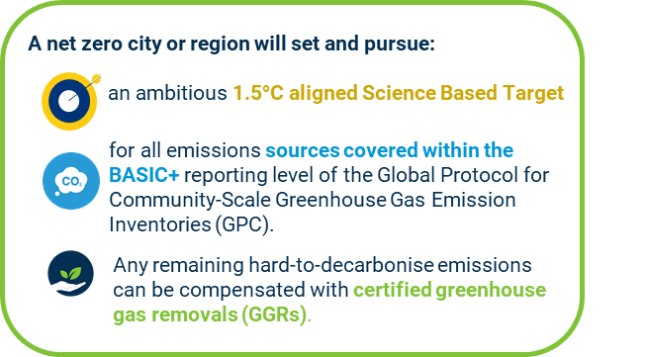
This aligns the definition for a net zero city or region with the SBTi’s definition for a net zero company. We have therefore used a 1.5°C aligned Science Based Target to determine the pace of reduction in carbon emissions, to ensure that Oxford it is on track to net zero by 2040.

Baseline emissions
Baseline data was sourced from publicly available datasets, such as BEIS and DfT, along with data from the Oxford City Council where available. These data sources represent the most recent annual data set, and where there were gaps, 2018 forecast data was used. The scope of the baseline is in keeping with the best-practice GHG Protocol for cities (GPC), which is consistent with PAS 2070. According to the protocol, the city footprint should, as a minimum, be inclusive of Scope 1, 2 & 3 (waste) emissions, including:
- Energy-use in buildings;
- Grid electricity;
- Road transport across Oxford; and
- Waste generation and management across the city (including domestic and commercial).
A summary of the 2018 baseline is shown in Figure 1 below.
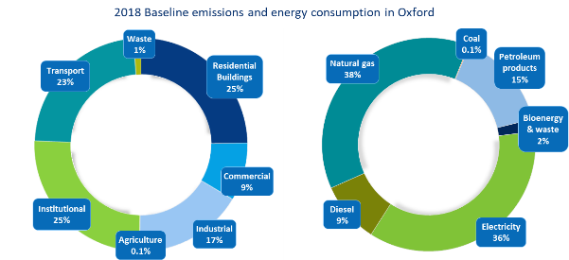
3,139 GWh
736.5 ktCO₂e
Figure 1: 2018 baseline emissions by sector (excluding land use, left) and 2018 baseline energy consumption by fuel type (right)
The majority (nearly 60%) of the 2018 emissions arise from the buildings sector (434 ktCO₂e) (including residential, commercial, industrial, and institutional including universities, colleges, councils, and NHS buildings), largely due to the high proportion of gas-heated buildings. Transport is the second largest contributor to Oxford’s emissions and accounted for 171 ktCO₂e in 2018, with private cars being the main source of emissions.
As data emerges for more recent years it will be important to update this baseline to understand the impacts of changes, such as the global pandemic.

Carbon pathway
Figure 2 illustrates the significance and scale of the challenge towards net zero by 2040. It compares the previous and updated net zero scenarios for Oxford, as well as indicative target pathways to align with a 1.5°C Science Based Target and the UK’s net zero by 2050 target. The Science Based Target pathway uses an absolute contraction method (-4.2% per annum) to calculate Oxford’s share of the global reductions required to limit global temperature rise to 1.5°C; and the CCC’s Sixth Carbon Budget provides a sectoral breakdown of the percentage reductions needed to comply with the UK’s Net Zero 2050 target. The new scenario is compliant with the SBTi 1.5°C pathway and the UK government’s Net Zero 2050 target by 2040 and goes beyond what is necessary to achieving those targets in the near and medium-term.
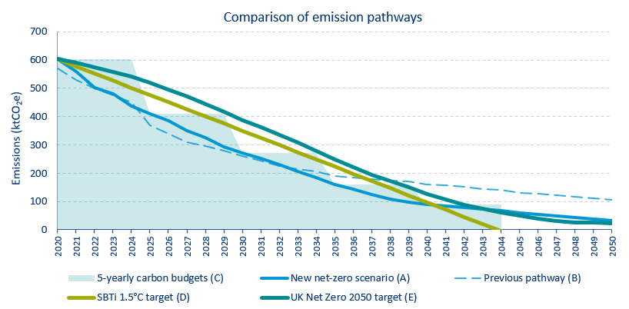
Figure 2: Emissions pathway : A) new net zero scenario”; B) previous Pathway; C) interim 5-yearly carbon budgets; D) 1.5°C science-based target; and E) UK net zero 2050 target
Projecting emissions over the 22-year period from 2018-2040 has been used to determine five-yearly carbon budgets for the city, aligned to the 2040 net zero target.
Table 1: Five-yearly carbon budgets 2020-2040
Net zero target | 2040
Total carbon budget (2018-2040) | 7,634 ktCO₂e
Carbon Emission reduction by (Cf. 2018 base year)
2025 | -44.3% | 409.5 ktCO₂e
2030 | -63.2% | 270.5 ktCO₂e
2035 | -78.3% | 159.5 ktCO₂e
2040 | -87.9% | 88.7 ktCO₂e
Carbon to be offset in 2040 |  | 88.7 ktCO₂e

While there is some potential for further decarbonisation post-2040 (mostly from the decarbonisation of waste), there is still uncertainty around how to decarbonise hard-to-reach areas, such as HGV transport, which is demonstrated by a flattening out of the curve. Although, it is possible that technology innovations during the course of the transition could unlock further decarbonisation in the future, it is also possible that some residual emissions in 2040 may need to be offset.
ZCOP should prioritise reducing its emissions through direct interventions, as is the focus of this Action Plan. Once opportunties to reduce emissions through direct interventions have been maximised, any residual emissions should be balanced with emission removals from within Oxford’s immediate area, such as afforestation projects on the land it owns (insetting). If there are only a few viable emission removal options available, or after the potential for emissions removals have been exhausted, only then should high-quality carbon removal offsets be purchased.
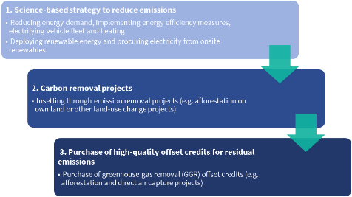
The GHG Protocol’s Carbon Removals Standard/Guidance, is currently under development and will, alongside the Land Sector Guidance, determine how to account for purchases of emission removals. The final guidance is not expected be released until late 2021/early 2022. Therefore, it is advisable that ZCOP finalise its offsetting strategy once these have been fully established. This will also ensure that technology developments which may reduce projected residual emissions further can be considered, thus increasing direct action to reduce emissions, and reducing the overall cost of offsetting. In the Roadmaps it is suggested that this begins in 2030 in preparation for 2040. For individual partners looking to achieve net zero before 2040 the above hierarchy should guide their approach to offsetting.

Sector analysis
A sectoral breakdown of the results from the updated scenario shows the amount of decarbonisation required for each sector to meet Oxford’s 2040 net zero target. Figure 3 shows the emissions reductions from 2020-2040, with percentage change overlaid.
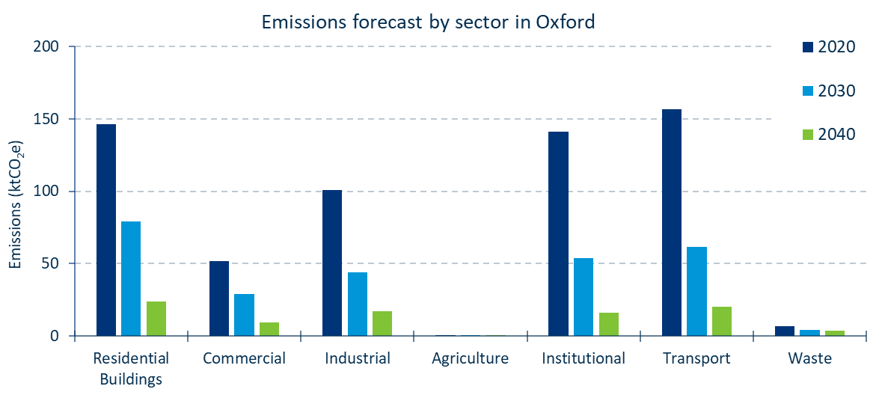
-84%
-82%
-82%
-89%
-87%
-43%
Figure 3: Model output: 2020, 2030 and 2040 emissions projections for each sector considered in the pathway analysis
Details on the transition by sector can be found in the full report. A summary of key sector projections is included in the Appendix of this summary.

Policy gap
It is important to recognise that to achieve its ambitious 2040 net zero target, Oxford will require a considerable step-up in support from national government, in the form of clear leadership, policy and regulatory frameworks and funding are required. Government intervention is crucial for Oxford, and other areas in the UK, to achieve their net zero goals. The UK Government’s Ten Point Plan and Energy White Paper must be backed by policy to give local authorities and stakeholders the power and support to implement their net zero strategies. The full report draws out a few of these key areas in more detail. To assess the impact of key national dependencies on achieving the ZCOP’s 2040 net zero target, a ‘Business as Usual’ (BAU) scenario has been modelled considering current policies and initiatives without any assumptions around future policies and compared to the net zero 2040 scenario. The projection is primarily based on BEIS future energy projections and the impact of ongoing initiatives in Oxford that are within the control of local government and ZCOP partners.
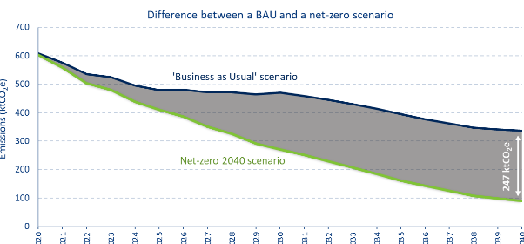
Figure 4: ‘Business as usual’ scenario (blue) and the net zero 2040 scenario (green), with the policy deficit represented by the area (grey) between the two scenarios

Roadmaps
Decarbonisation roadmaps have been developed for five keys sectors - domestic, commercial, industrial, institutional and transport. They are fed directly by the scenario modelling, extracting the key milestones for each sector to map out a timeline of ‘what needs to happen, and by when’ for Oxford to be on-track to achieve net zero by 2040. The roadmaps provide an important step in breaking down the overall net zero vision into more tangible pieces, looking at 5-yearly periods by sector, and form the basis from which the actions set out in the Action Plan have been developed.
The over-arching strategic roadmap lays out the 5-yearly sectoral decarbonisation requirements, positioning them alongside wider contextual changes at national and regional-levels drawn from across the sector-specific roadmaps. The strategic roadmap is supported by the sectoral roadmaps providing a more detailed view of the technical net zero transition requirements within each sector and provide a common ‘vision-setting’ reference point for the ZCO Partnership to use in allocating focus and developing actions going forwards.
Each roadmap also includes a context pathway, summarising wider information on activities that are expected to support the transition to net zero, such as national, regional, and local regulations, policies, and plans. This contextual information has been drawn from national and regional strategic documents, as well as local authority area plans, programmes, and policies, and some have themselves been included as key enabling factors and focal points of momentum. For consistency, the contextual information included has been selected on the grounds that the policy, proposal, or target could accelerate, be a dependency or even a challenge for the relevant net zero pathway requirements of that sector.

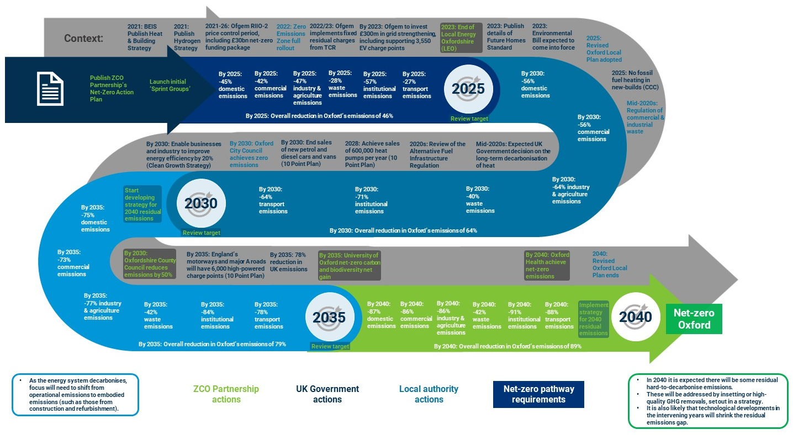
Strategic Roadmap
The sector roadmaps are available at the end of this summary.

Action plan
The Action Plan provides a clear initial direction and series of steps for the ZCO Partnership to follow to set Oxford on a path to net zero by 2040. It lays out a pipeline of near-term and mid-term priority actions for the partnership to consider and drive forwards using Sprint Groups. It offers a starting point around which to build momentum and galvanise partners, as opposed to an exhaustive list of all actions required to achieve the 2040 net zero Oxford target. This action plan has been developed specifically for the ZCO Partnership to own and implement.
Action Plan development process
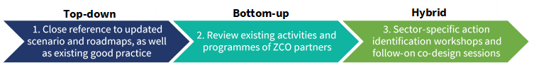
The full report sets out more detail on the concept, funding sources, implementation steps, owners, costs, carbon savings, dependencies, and risks of the actions. In addition to the 21 key action concepts for progression by the partnership (summarised below), wider suggestions from partners have also been included in the full report, as well as likely themes that will require further consideration and focus between 2030-2040.

Actions summary
Policies & regulation
P1 – Building on the Local Plan | Explore opportunities to build-on the Local Plan to go beyond Part L building regulations, across energy efficiency, fossil-fuel heating, private car usage, and accessible waste disposal.  Investment cost: £97,000  This reflects the per annum pro-rata part-time salary of an Oxford City Council officer-grade resource, who can support delivery for 4 years (from 2022 till the adoption of the revised Local Plan in 2025).  Carbon impact: 4 ktCO₂e  The carbon impact estimate has been calculated based on improving the energy efficiency of new builds only, and does not include transport or waste. The figure denotes the potential savings possible on top of those expected from existing Local Plan policy RE1 (26 ktCO₂e).
P2 – Streamlining retrofit within conservation areas | Improve understanding of heritage and conservation-related constraints to retrofitting the building stock of the city, through pilots, demonstrations, and technical advice and support for householders and installers/suppliers.

Research & development
R1 – Developing template retrofit buildings | Tackling the lack of real-world information (both on technical performance and business case) around different building retrofit options, and how to deliver them by demonstrating measures and the retrofit process.  Investment cost: £94,000  This reflects the pro-rata part-time salary of an Oxford City Council officer-grade resource, who would oversee delivery for 1 year, as well as capital investment required across four template buildings.  Carbon impact: 8.7 tCO₂e  The direct carbon impact results from the retrofitting of the four buildings. However, the aim is for the templates to spark an acceleration of similar retrofits, particularly amongst Council-owned stock. This is uncertain and harder to quantify. Oxford City Council owns 14% of Oxford’s housing stock (~8,700 dwellings), retrofitting this number to the same level as the templates would result in carbon savings of 16 ktCO₂e.
R2 – Establishing building stock inventory and pipeline | Develop detailed building stock inventory for Oxford, especially filling in the commercial building stock data gap. This could provide the information basis for local area energy planning, where detailed modelling of different heat, energy efficiency and flexibility technologies are assessed at address-level, to inform a programme of action.
R3 – Whole system network review | SGN and SSEN to scope and undertake whole system review to establish ability to deliver the required energy within key timelines.
R4 – Mini-hydrogen network feasibility study | Conduct a feasibility study on a mini hydrogen network in Oxford, bringing together interested parties to map out the different potential use-cases for hydrogen across the city. (Initial discussions have brought together two ZCOP partners with local gas network provider SGN to collaborate on this.)

Capital investment
C1 – Bulk-buying scheme for solar PV and heat pumps | Set up a bulk buying scheme for low carbon equipment (solar PV and heat pumps) to enable local businesses, organisations, and households to benefit from lower bulk purchase prices.  Investment cost: £48,000  This reflects the pro-rata part-time salary of an Oxford City Council officer-grade resource, who would oversee delivery for 2 years. However, if the scheme’s delivery was fully outsourced to an external organisation (such as Solar Together) resource costs would likely be reduced. The expected private investment cost (end-users purchasing the equipment) is £7.6 million this includes purchases of solar PV units by domestic and commercial users, and ASHP units by domestic users. Larger commercial ASHPs are not included as they need to be highly tailored to the building, and therefore are less suited to bulk-buying.  Cost saving impact: £3.2 million  Bulk-buying provides a 31% cost saving for solar PV units, and a 26% cost saving for ASHP units. The total cost saving is spread across 1,200 households and 200 businesses.  Carbon impact: 31 ktCO₂e  The direct carbon impact results from the avoided emissions of solar PV replacing grid electricity consumption, and ASHPs reducing gas consumption. This is totalled over a 21-year equipment lifespan, accounting for UK grid decarbonisation.
C2 – Greening last-mile delivery | Pilot a number of urban consolidation centres around the edge of Oxford.  Develop a quiet deliveries scheme.
C3 – Domestic retrofit programme | Establishing a programme to scale domestic retrofit across social and private housing. Extending and building on the delivery experience and expertise of LCH’s Cosy Homes programme, and relevant Action Plan actions (R1, R2 and P2).
C4 – SME sustainability support and interest-free loans | Building on the technical assistance approach developed by OxFutures and further refined by ESOx, by combining it with sustaining financial incentives to drive higher retrofit uptake amongst SMEs.
C5 –Establishing campus-scale integrated energy systems | Identify potential 'energy campus' areas within Oxford (e.g. universities, colleges, businesses, science parks), taking account of considerable heritage limitations, and explore the potential for cost-optimised energy system transformation, establishing joined-up generation, storage and demand management.
C6 – Deploying EV charging infrastructure | Install EV charging infrastructure across a strategically selected series of sites (spanning car club locations, light commercial vehicle parking and deprived districts).
C7 – Improving bus journey times and regularity | Bring together Oxford’s bus operators to identify the key 'pinch points' currently slowing bus routes and disruptive service regularity. Discuss these with the Oxford City Council planning and transport teams with an aim to developing implementable trunk-route solutions that improve bus journey times in and out of Oxford and make buses the priority mode.

Behaviour change, communication & education
B1 – ZCOP Strategic communication plan | Develop a centralised plan for communicating with Oxford residents and businesses to ensure a clear and consistent communication approach from the ZCOP.
B2 – Public dashboard for monitoring ZCOP progress | Create an online public dashboard to communicate progress against decarbonisation objectives.

Governance & stakeholder collaboration
G1 – Knowledge transfer platform | An Oxford Knowledge Transfer Partnership, matching up academics with businesses that require this expertise, as well as businesses with other businesses they can learn from.
G2 – Active travel commitments | ZCOP partners to commit to supporting the Connecting Oxford and Zero Emissions Zone interventions, which are critical to freeing up the roads for cycling access  Partners to lead by example by installing active travel support infrastructure and measures.  Costs  Birmingham provided up to £10,000 to schools to cover the costs of: secure cycle parking, showers, workbenches, bikes for staff use, bikes for cycle training and accessories (locks, lights, helmets, tools).  Impacts  Annual economic benefits are estimated at between £600-640 per additional cyclist on urban roads.
G3 – Joint lobbying strategy | A significant amount of additional central government support (whether policy, regulation, or funding) is required if Oxford is to achieve its net zero 2040 target. An advocacy strategy should be developed focused on key asks.

G4 – Joint funding applications | Funding applications that bring together several partners and offer scale are often more likely to be successful. The ZCOP offers a potential umbrella under which the key players in Oxford can be brought together to plan and submit funding applications that will benefit the city.

Skills & supply chain
S1 – Collaboration with the education sector on low carbon skills | Develop a suite of joined-up low carbon training and re-training courses across educational establishments. This should include offering green apprenticeship and vocational courses for sought after retrofit skills across education providers (certified by appropriate bodies), green ‘year in industry’ opportunities to foster links with Oxford’s commercial and industrial sector, and building-on existing successes such as the Abingdon & Witney College Green Construction Centre.  Costs  Cambridgeshire and Peterborough Combined Authority is delivering a three-year Health and Care Work Academy programme in partnership with a local college, which will support 2,100 clients at an average cost of £2,482 per client. The programme was funded by a £5.2m bid to the Department for Work & Pensions.  Impacts  Since its inception in 2018, 567 learners have joined the programme, with 107 now working in the sector.
S2 – Priming the low carbon retrofit supply chain | Gather partners and wider parties who are aiming to complete ambitious retrofit programme to issue demand signals, via advance notices, to encourage retrofit companies to invest in upskilling and accreditation.
S3 – Accelerating innovative cleantech deployment in industry | Matchmaking industrial facilities and commercial actors with innovations from local industrial and large commercial businesses and cleantech/innovation companies.

Cross-cutting
CC1 – Strengthening domestic grid connections | Digitalisation of domestic grid connection information to provide better information on grid capacities and need for reinforcement.
CC2 – Exploring funding options | Investigate funding options available to the ZCOP to implement the action plan pipeline.
CC3 – Engaging with flexibility markets | Encourage ZCOP partners to show Oxford-wide leadership and develop their experience of grid energy flexibility by engaging with innovations such as the new flexibility market created by Project LEO, or through consumer focussed interventions such as time-of-use tariffs.

Next steps
While the numbers set out in the roadmaps may be seen (and practically used) as specific milestones, it is important that a degree of flexibility is considered. This is especially relevant in the mid-term (late 2020s into the 2030s) where the context is less concrete and there may be changes, in terms of strengthened or weakened enabling factors, new innovative solutions, or national government steer. In the face of this uncertainty, an approach to that builds-in resilience is to consider the net zero pathway requirements as indications of ‘level of effort’, which could be roughly transposed across to other solutions as needed. In addition to this, focusing on the nearer-term periods of the roadmap (up to 2025 and 2030), and accepting that uncertainty will require a substantial degree of flexibility regarding later years, will ensure practical progress is prioritised above defining a set path. Periodic reviews of the scenario and roadmap (at least every 5 years) will support readjustments based on changing circumstances, as well as evidence progress towards the overall 2040 net zero target.
The action plan sets out several immediately implementable actions for the ZCOP to focus on. Establishing the Partnership’s first sprint groups to work collaboratively on these key actions will be a logical next step to turn the ZCOP’s shared ambition of net zero emissions by 2040 into reality. These task-and-finish groups will gather the key ZCO partners required for delivery of a particular action. Once the action has been completed, the sprint group will dissolve, and a new group will be established around the next selected action, with likely different partners involved. This will ensure groups are agile, with regular, fresh momentum, comprise of the relevant partners and experts, and that workload is spread across partners.
Building on the identified policy deficit, while initial progress can be made by the city alone, achieving a target of this ambition depends on a considerable step-up in national-level policy and funding support. The ZCOP will need to co-ordinate joint lobbying and funding applications to ensure the city secures the support it needs.
Additionally, some actions will require wider collaboration, beyond those organisations already involved in the Partnership. Therefore, all communities, organisations and businesses in Oxford are encouraged to commit to reducing carbon emissions and identify opportunities to collaborate towards achieving net zero.

Appendix - Key sector projections
Refer to the full report for explanation and assumptions

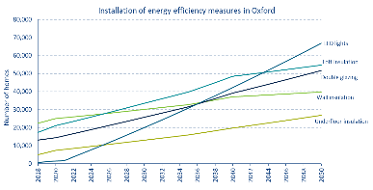
Figure 5: Required rollout of energy efficiency measures in Oxford’s existing housing stock
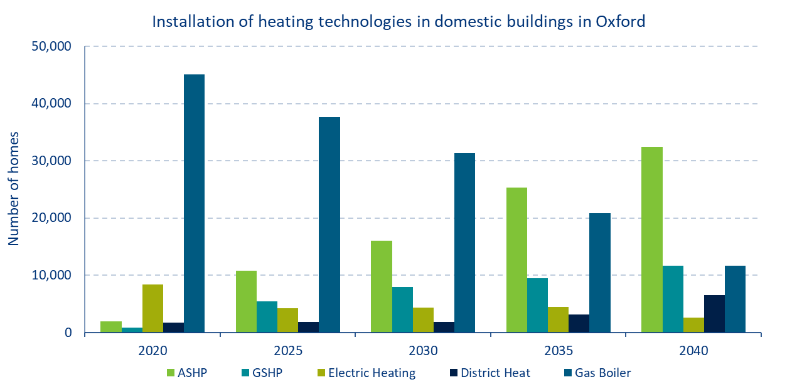
Figure 6: Required deployment of heating technologies in Oxford’s existing housing stock

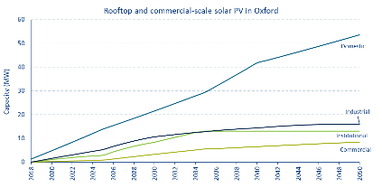
Figure 7: Required rollout of solar PV across sectors

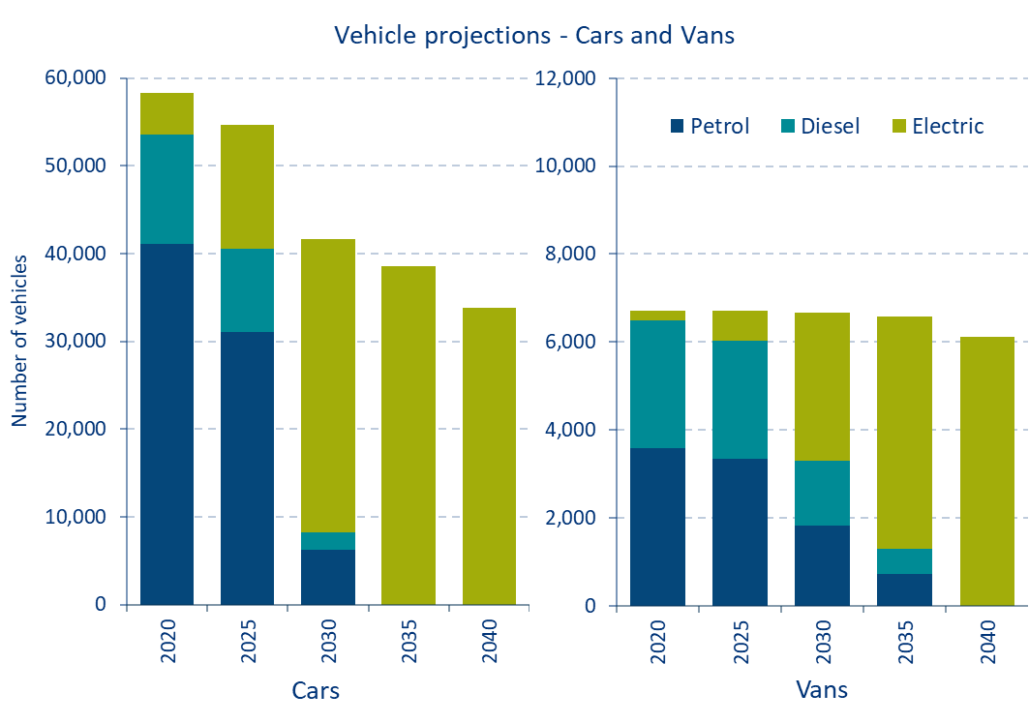

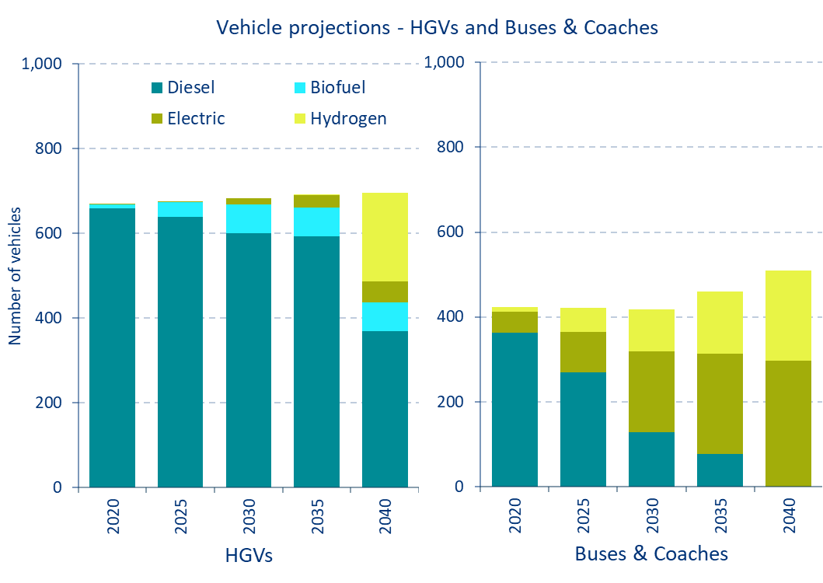
Figure 8: Vehicle projections to 2040 by fuel, showing (from top left to bottom right) cars, vans, HGVs and buses & coaches

Sector roadmaps
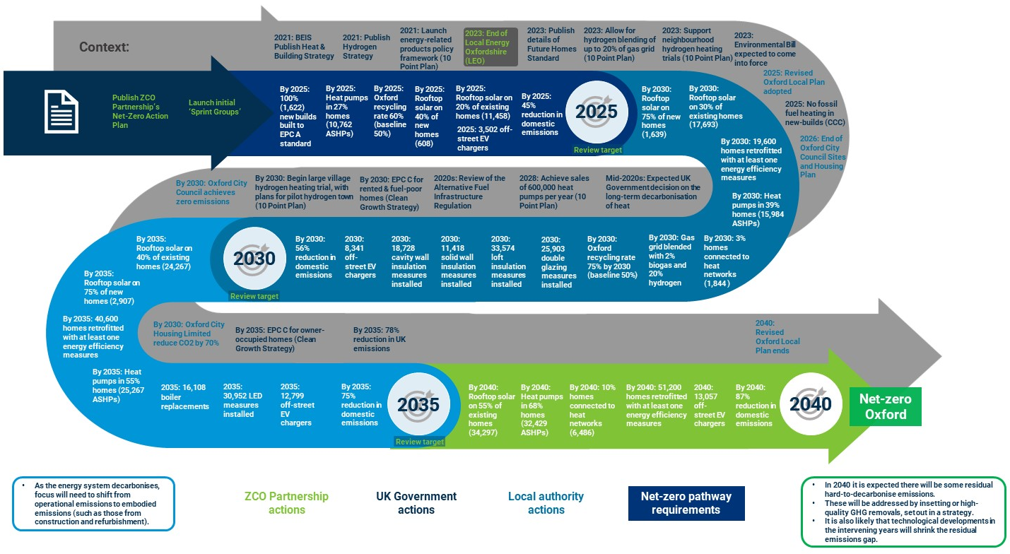
Domestic
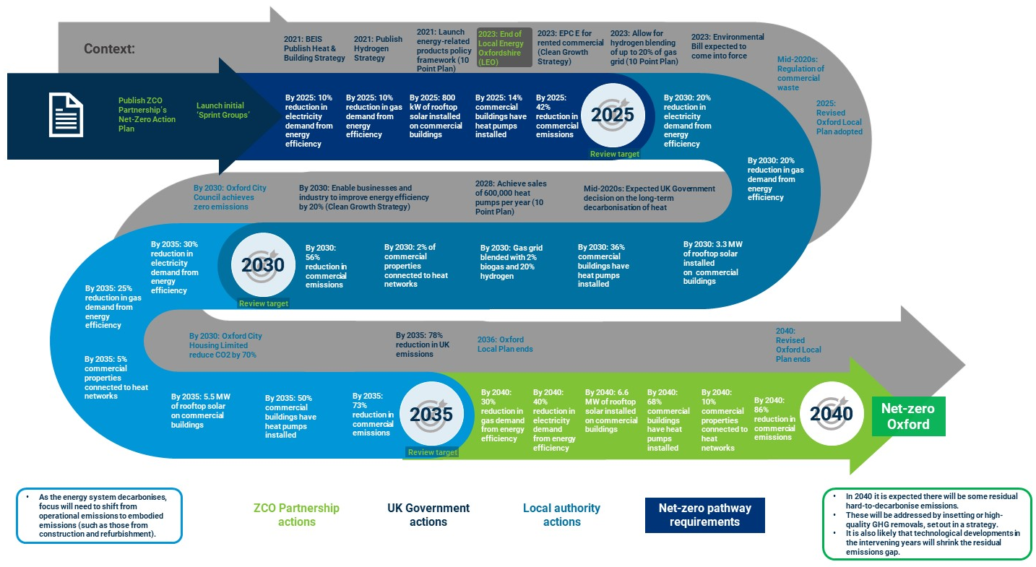
Commercial
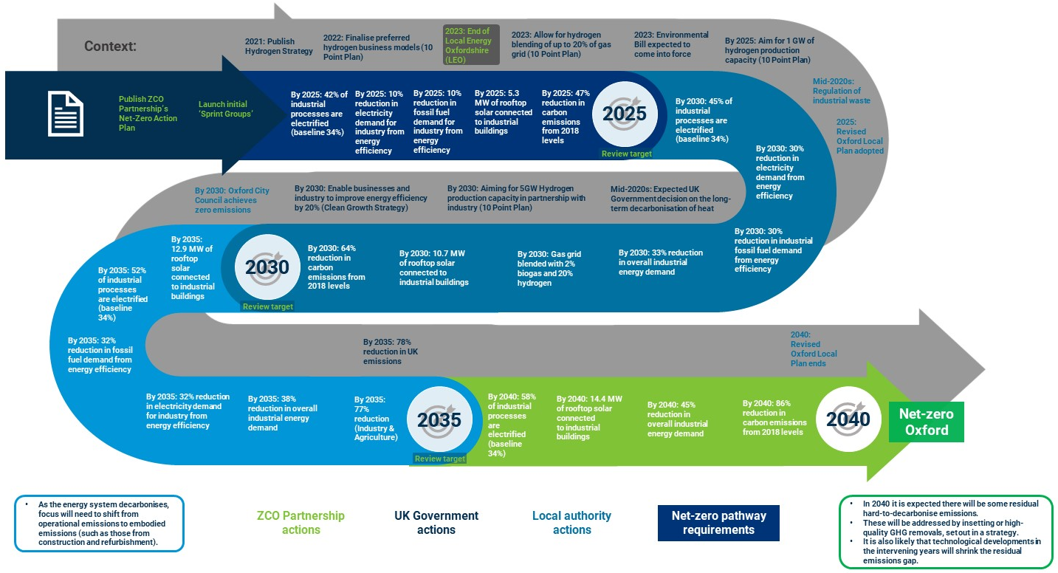
Industrial
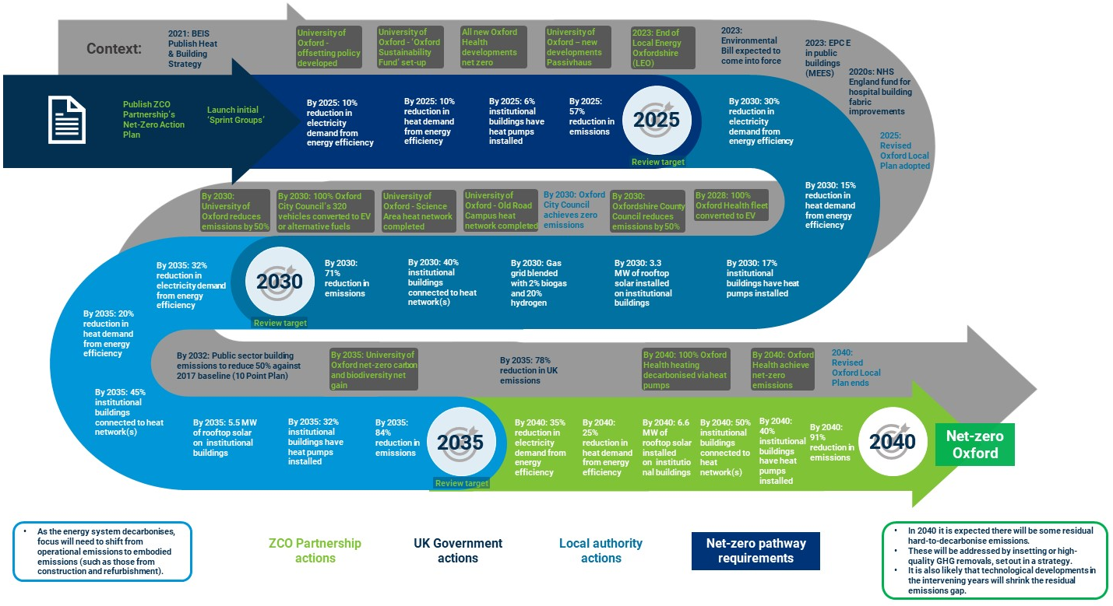
Institutional
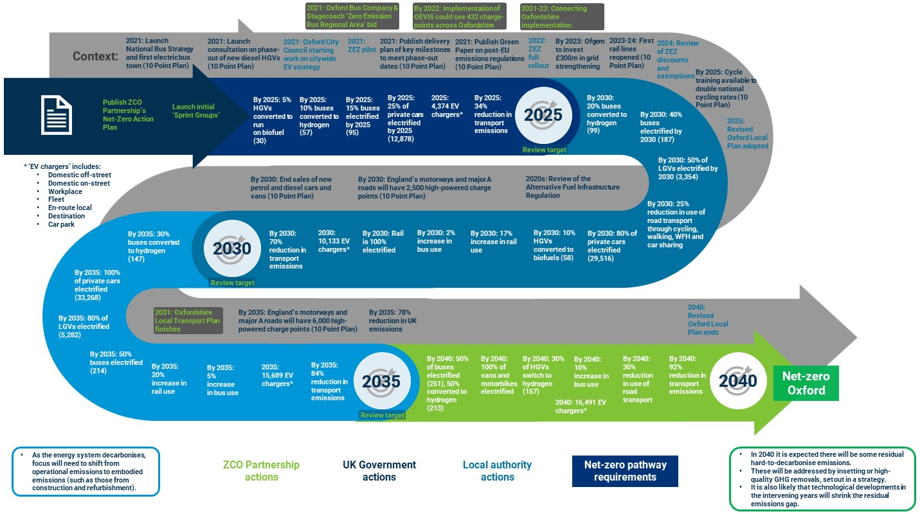
Transport

Given the minimal contribution from the agricultural sector to carbon emissions in Oxford, and the aim for the roadmaps to be feeders for action in priority focus areas, a separate roadmap for agriculture has not been developed. Additionally, waste requirements have been included within the domestic, commercial and industrial roadmaps.
An indication of potential costs and impact have been provided for five key, near-term actions in the pipeline. These are high-level and should be taken to indicate ‘order of magnitude’. For three (P1, R1, C1), it has been possible to calculate investment costs and carbon savings. For others (G2, S1), the highly uncertain nature of the action details at this stage have necessitated taking a ‘case study’ approach, laying out costs and impacts from similar actions implemented elsewhere. For the wider pipeline, the specific activities of the actions need to be further defined before savings and costs can be estimated.
Oxford City Council, ‘Zero Carbon Oxford Summit’. Available from: https://www.oxford.gov.uk/info/20291/climate_emergency/1431/zero_carbon_oxford_summit
BEIS, ‘Sub-national electricity consumption data’. Available from: https://www.gov.uk/government/collections/sub-national-electricity-consumption-data; BEIS, ‘Sub-national gas consumption data’. Available from: https://www.gov.uk/government/collections/sub-national-gas-consumption-data
Department for Transport, ‘Vehicles statistics’. Available from: https://www.gov.uk/government/collections/vehicles-statistics
GHG Protocol, ‘Global Protocol for Community-Scale Greenhouse Gas Emission Inventories’. Available from: https://ghgprotocol.org/greenhouse-gas-protocol-accounting-reporting-standard-cities
CCC, ‘Sixth Carbon Budget’. Available from: https://www.theccc.org.uk/publication/sixth-carbon-budget/
GHG Protocol (2019), New Greenhouse Gas Protocol Standards/Guidance on Carbon Removals and Land Use, https://ghgprotocol.org/blog/new-greenhouse-gas-protocol-standardsguidance-carbon-removals-and-land-use
Greenhouse Gas Protocol – ‘Carbon Removals and Land Sector Initiative’
The Carbon Trust sits on the advisory Technical Working Group for the GHG Protocol’s Carbon Removals guidance.
BEIS (2020), ‘The ten-point plan for a green industrial revolution’. Available from: https://www.gov.uk/government/publications/the-ten-point-plan-for-a-green-industrial-revolution
BEIS (2020), ‘Energy white paper: Powering our net zero future’. Available from: https://www.gov.uk/government/publications/energy-white-paper-powering-our-net-zero-future
Available from: https://assets.publishing.service.gov.uk/government/uploads/system/uploads/attachment_data/file/742451/typical-costings-for-ambitious-cycling-schemes.pdf
Available from: https://webarchive.nationalarchives.gov.uk/20110407100933/http:/www.dft.gov.uk/cyclingengland/site/wp-content/uploads/2009/03/planning-for-cycling-report-10-3-09.pdf
Available from: https://www.local.gov.uk/case-studies/experiences-employment-and-skills-devolution-cambridgeshire-and-peterborough-combined
Ibid.
Available from: https://project-leo.co.uk/about/

